**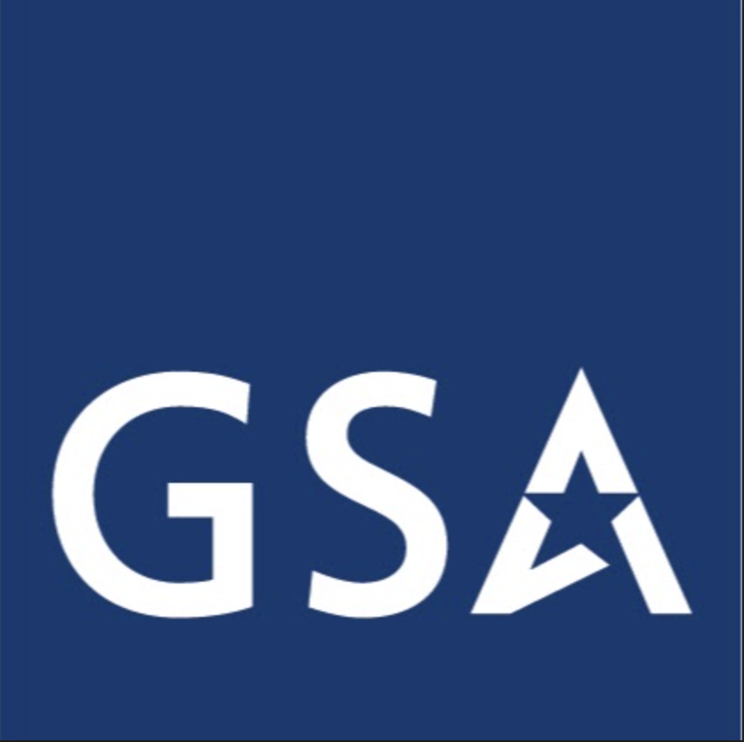******

# Accessibility in Procurement Guide

**iteration 2 (November 2, 2023)**

**Purpose 1**

**Compliance 2**

**Pre-solicitation 2**

**Defining the requirement 2**

**Market research 2**

**Stakeholders** **2**

**Accessibility requirements 3**

**VPAT® templates** **3**

**Alternatives 4**

**Tools 4**

**Sample language for an RFI: 5**

**Requests for quotes (RFQs)/request for proposals (RFPs) - “solicitations” 5**

**Section 508 language 5**

**Pass/fail criteria 6**

**Trade/off evaluation factors: 6**

**Deliverable or demonstration 6**

**Sample language on instructions for accessibility 7**

**Post-award 8**

**Contractor performance assessment report system (CPARS) 8**

**Sample language for QASP/AQL 8**

# 

## 

## 

## Purpose

This guide focuses on accessibility in procurement. Contracting Officers (CO) and Contract Specialists (CS) play an integral role in the information and communication technology (ICT) lifecycle. Including them early on in the process will ensure optimal results in ensuring ICT is to meet Section 508 compliance or ensure that the product is able to have a good customer experience for all users (including those with disabilities). The procurement process is very dynamic and can be very overwhelming. The purpose of this guide is to align acquisition professionals throughout the federal government with its process and mission; provide a user-friendly approach to incorporating accessibility into the lifecycle of ICT projects; and provide a tool to support the inclusion of procurement personnel throughout the process. This guide follows agile principles and should be iterated on, as needed. It can be applied to any federal agency.

## Compliance

ICT must be accessible to people with physical, sensory, and cognitive disabilities. Access to ICT is addressed by [U.S. Access board standards and guidelines for Section 508 of the Rehabilitation Act and Section 255 of the Communications Act](https://www.access-board.gov/ict/). These ICT accessibility standards include requirements that ensure compatibility with assistive technology (AT) used by people with disabilities.

Recently, accessibility was added to [Federal Acquisition Regulation (FAR) Subpart 39.2 - Information and Communication Technology](https://www.acquisition.gov/far/subpart-39.2) so that the role of procurement is clearer.

### Pre-solicitation

### Defining the requirement

The most important step in acquiring accessible products is defining the requirements. What is the project team, client, partner, etc. interested in procuring? What are the minimum specifications? Is there a timeline? Is it a standalone item, or is it something that involves multiple items in order to make the requirement successful?

### Market research

Documenting what products are currently available in the market is important to understand if the Government can meet its needs with a commercial-off-the-shelf (COTS) item. This can be done through Requests for Information (RFIs), sources sought notices, industry days, general internet searches, etc.

When looking at vendors and their products, look for Accessibility Conformance Reports, Accessibility Statements and any policy or research work that they may have done on digital accessibility.

### 

### Stakeholders

In some instances, a particular dollar threshold will require higher-level approvals and more stakeholders. At the basic level, personnel from the technical, acquisition, and financial offices should be included from the beginning. Although not always a requirement, involving legal can be necessary to avoid any issues later on, so keep that in mind as questions arise during the process.

The Information technology (IT) or designated office should be involved as early as possible to ensure all agency and federal-level approvals are met. Keep in mind, this process can be lengthy and impact the acquisition of a particular product, especially with regard to security requirements.

### Accessibility requirements

Before doing market research, understanding accessibility regulations will help you identify compliant products.

An RFI can request a vendor to provide an updated copy of its [Voluntary Product Accessibility Template](https://vdi.anywhere.gsa.gov/vpn/index.html) (**VPAT**®) or similar Accessible Conformance Report (ACR). An ACR is a document that is a vendors attestation about the accessibility of the information and communication technology (ICT) products such as software, hardware, electronic content, and support documentation that they produce. It should describe how well it meets (conforms to) the [Revised 508 Standards](https://www.access-board.gov/guidelines-and-standards/communications-and-it/about-the-ict-refresh/final-rule) for IT accessibility. Ultimately, and ACR is a sales document, and it may or may not reflect the accessibility of the product.

The most common format is [Voluntary Product Accessibility Template](https://vdi.anywhere.gsa.gov/vpn/index.html) (**VPAT**®), but there are others such as OpenACR which was developed for the GSA. A vendor’s ACR may be linked from their accessibility statement, but a quick search may find it if it is publicly available. Some vendors choose not to post ACRs on their site, but will provide them on request.

It is critical that one or more of the stakeholders be familiar with the ACR. An agency may have a point of contact who may serve as the subject-matter expert (SME) to review and comment on accessibility claims made by a vendor. This will be necessary during the process, especially evaluating accessibility during pre- and post-award. The [508 program managers](https://www.section508.gov/tools/program-manager-listing/) for the particular agency are a great resource.

As an acquisition professional, it can be important to remind vendors that they are responsible for ensuring that their accessibility claims are both current and accurate. It is also important that the vendors have an up-to-date ACR. Ideally, ACRs would be provided for every minor release of an ICT. Given the pace that technology is produced, updating it every six months would be good. Certainly, if an ACR is over a year old its claims are likely out of date.

### 

### ACR templates

* [Voluntary Product Accessibility Template® (VPAT®) Revised Section 508 Edition, March 2022 (.doc, 369KB, 26 pages)](https://www.itic.org/dotAsset/353efda0-598d-4593-aa53-f4f1f0f61d82.doc)
* [Voluntary Product Accessibility Template® (VPAT®) WCAG Edition, March 2022 (.doc, 227KB, 15 pages)](https://www.itic.org/dotAsset/7edcd54d-c6a6-4649-8375-4a0f0c68eff2.doc)
  + **Reference** [Web Content Accessibility Guidelines (WCAG) 2.1](https://www.w3.org/TR/WCAG21/) [**WCAG 2.2 quick reference currently being updated**](https://www.w3.org/WAI/WCAG22/quickref/)**.**
* [OpenACR](https://gsa.github.io/openacr-editor) is a new model produced for GSA and is available as a web form

**Reminder: Version control. Ensure all versions for templates and other references are current and accurate.**

## Alternatives

What if a product or service does not meet all the accessibility requirements? All software has bugs, some of those are going to be accessibility bugs.

[Section E202.7 Best Meets](https://www.access-board.gov/ict/#E202.7) of the Revised 508 Standards states that if one cannot find an accessible commercial solution, an agency should procure the ICT solution that *best meets* the standards consistent with business needs. If no technically acceptable alternative fully conforms to the Revised 508 Standards, select the alternative that best meets the standards when making an award, and request a “best meets” exception. Where product features or components are not fully accessible, the agency is required to make available, upon request, an alternative means of accessing the information or functions supported by the ICT.

It is important that if the Best Meets criteria is used, that the decision is well documented to ensure that if the procurement decision is contested by a vendor, that it can be defended.

### Tools

When developing the solicitation, it is recommended to utilize GSA’s [Accessibility Requirements Tool](http://www.section508.gov/art/) (ART). This is a user-friendly, web-based form that will develop language for including accessibility requirements in a solicitation. The tool allows users to select criteria and seamlessly paste it into the solicitation or save it as an attachment.

### Sample language for an RFI:

“Please provide a copy of the most updated version of the Accessibility Conformance Report(s) (ACR)). In addition, please provide the contact information for an individual most qualified to speak to the accessibility of this product or service.”

## Requests for Quotes (RFQs)/Request for Proposals (RFPs) - “Solicitations”

When developing a solicitation, there are multiple ways to include accessibility as an evaluation factor or required item in the vendor’s response. In addition to ART, which populates the language for a specific requirement, it is in the government’s best interest to ensure the vendors understand the specific requirements as it relates to accessibility. Plain language is also an essential part of accessibility in the procurement process.

Sample questions that can be included in the solicitation and/or technical demonstration:

* In your proposed solution, please explain/demonstrate how accessibility will be integrated into the design, development, and testing processes. What is your process for resolving any accessibility bugs found or reported?
* In your proposed solution, please explain/demonstrate under what circumstances accessibility conformance reports (ACR) will be updated and the plan for accessible communication of these updates.
* In your proposed solution, please explain/demonstrate your ability to provide accessibility-related customer support with regards to training, troubleshooting, and regular updates.

(Sample evaluation criteria for Accessibility can be included here: work in progress)

**Solicitation**

GSA has a [Solicitation Review Tool](https://www.section508.gov/buy/solicitation-review-tool/) (SRT) which can be used to aid in this phase of the process. With SRT, agencies will have the information to inform decisions on which solicitations warrant additional Section 508 requirements, those that warrant amending the solicitations to add requirements before selection decisions are made by the agency.

## **Section 508 Language**

In addition to the ART tool, agencies may have supplemental Section 508 language, and the acquisition team is advised to ensure it is using the most recent version. It may be tailored accordingly.

Always keep in mind to ensure documents being posted or received are also accessible. PDF files often have accessibility problems with them. It is a best practice to also include the original source documents, if possible, as they can often be more accessible. There are a variety of tools to aid in making documents accessible Spreadsheets are particularly bad when converted to PDFs. Finally, avoid using scanned documents; use images only if absolutely necessary. Scanned documents usually need to have alt text added manually to enable even basic navigation of the content for screen reader users. It also makes it impossible to search, which also makes evaluation more difficult.

Similar to the RFI language, ask vendors for the contact information of an individual in its company who is qualified to speak to the Accessibility of the product/service.

## 

## **Pass/Fail Criteria**

The Government may require the vendor to provide a comprehensive statement on how its product is compliant with the Section 508 and other requirements detailed in the solicitation.

The solicitation may have indicated this requirement will be evaluated on a Pass/Fail basis. For instance, if the statement was provided as required by the solicitation, it would receive a “Pass” rating. Alternatively, a “Fail” rating would be given for unresponsive vendors who did not provide the required statement.

This may also be included as a general requirement and would be part of determining technical acceptability of a vendor’s submittal.

## **Trade/Off Evaluation Factors:**

This process will be more in-depth, as it will require the Technical team to develop a standard for which it will evaluate accessibility of the product(s) in response to the solicitation. Additionally, this will include what tool(s) will be used to conduct the evaluation. Will it be automated tools? Will it involve manual testing? How will consistency be maintained during the process across all responses?

This will also require the team to determine the importance of this factor. Is it less important, equal to, or more important than price? Government should be willing and able to pay a premium to a vendor whose product is more accessible. Keep in mind, this can only apply to the “Best Meets” criteria since that can vary. What will that look like? Is there a limit because of funding?

## **Deliverable or Demonstration**

The Government may have vendors submit the ACR, an Accessibility statement, provide a demonstration, or a combination of all the options.

The Government also has the option to use a vendor’s “sandbox” or tool to test its product/service. This process should involve legal as it may involve “gifting” or purchasing trial versions that will involve more than what is described in this guide.

The Acquisition team will develop guidelines for what will be used to evaluate the demo of the product, either by the Government or vendor, if this is required by the solicitation.

## 

## **Sample Language on Instructions for accessibility**

“Complete each Accessibility Conformance Report (ACR) in accordance with the instructions provided in the appropriate template. Each ACR must address the applicable Section 508 requirements referenced in the requirements document. Each ACR shall state exactly how the ICT meets the applicable standards in the remarks/explanations column, or through additional narrative. All "Not Applicable" (N/A) responses in the ACR must be explained in the remarks/explanations column or through additional narrative. Address each standard individually and with specificity, and clarify whether conformance is achieved throughout the entire ICT lifecycle (for example - user functionality, administrator functionality, and reporting), or only in limited areas of the ICT lifecycle.

1. Provide a description of the evaluation methods used to support Section 508 conformance claims. The agency reserves the right, prior to making an award decision, to perform testing on some or all of the vendor’s proposed ICT items to validate Section 508 conformance claims made in the ACR. Describe:  
   1. Your approach to incorporating universal design principles to ensure ICT products or services are designed to support assistive technology users or people with disabilities.
   2. Plans for features that do not fully conform to the Section 508 Standards.
   3. “Typical” user scenarios and tasks, including individuals with disabilities, to ensure fair and accurate accessibility testing of the ICT product or service being offered.

Prior to acceptance, the Government reserves the right to perform testing on required ICT items to validate the contract holder’s Section 508 conformance claims. If the Government determines that Section 508 conformance claims provided by the contract holder represent a higher level of conformance than what is actually provided to the agency, the Government shall, at its option, require the contract holder to remediate the item to align with the contract holder’s original Section 508 conformance claims prior to acceptance.”

# 

# **Post-Award**

This phase is one that may be overlooked, especially in terms of accessibility. Maintaining accessibility is crucial as simple updates or customizations can render a product inaccessible or broken.

Clients should be regularly reminding vendors of the importance of accessibility and ensuring that barriers that identified are prioritized and quickly resolved.

Accessibility testing should be done prior to code being pushed to a live website. Reporting will also need to be done for the [Government-wide Section 508 Assessment Criteria](https://www.section508.gov/manage/section-508-assessment/criteria-01/).

# **Contractor Performance Assessment Report System (CPARS)**

Since accessibility is a requirement for the product, it is important to include this as a performance factor in CPARS and other means of past performance tracking.

The Contracting Officer’s Representative (COR) should follow the Quality Assurance Surveillance Plan (QASP) provided by the Government or the Quality Control Plan (QCP) provided by the contractor. Either is sufficient, depending on what the Acquisition Planning team determined at the beginning of the process.

Acceptable Quality Levels (AQLs) are included in the relevant Quality Plan. What does success look like for Accessibility? How often will the COR do spot checks on the product? What are the incentives or considerations for products that exceed expectations or are inaccessible or broken?

# **Sample Language for QASP/AQL**

Note: this should tie into language included in the requirements document (performance work statement, statement of work, statement of objectives, etc.).

“The contractor is subject to regulations governing ICT. ICT must be accessible to people with physical, sensory, and cognitive disabilities. Access to ICT is addressed by board standards and guidelines under section 508 of the Rehabilitation Act and Section 255 of the Communications Act. These ICT accessibility standards include requirements that ensure compatibility with assistive technology (AT) used by people with disabilities; and Federal Acquisition Regulation (FAR) Subpart 39.2 “Information and Communication Technology”, which also governs the procurement of Accessible technology.”

An AQL is completed when testing is successfully completed using the contractor’s ACR.